Lead Retrieval Process
- Complete the order form. Once completed, you are directed to a confirmation page:
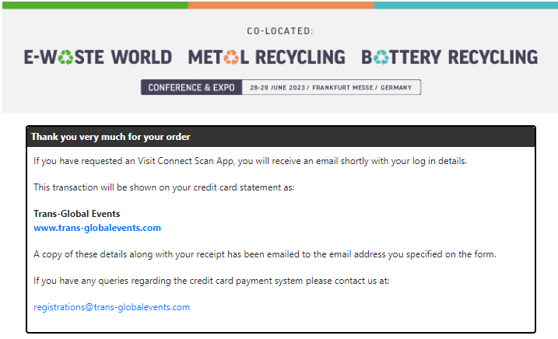
- An email is sent to Trans Global Events with the order details.
- TGE will add the order into Visit connect and a confirmation email is sent to the person on the order.
- The email contains 3 steps that should be followed to get started.
  - Download the Visit Connect app to your smart device(s).

  - Access your licence(s) and activate on each device. One licence per device.
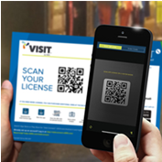
  - Activate your portal account to create bespoke questions, set targets, allocate licences, and access your leads.
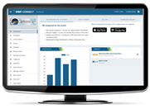
- Once the App has been downloaded, click on the ‘Access Licenses’ within the email confirmation. The takes you to a PDF which contains a QR code.

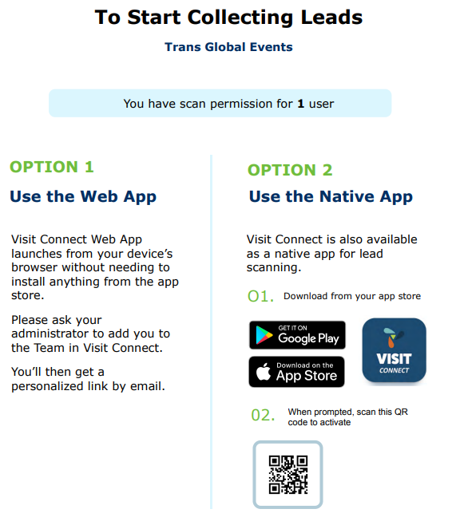

- Go into the Visit Connect app and scan the QR code. This must be done using the phone that is going to collect the leads.
- This takes you to the Licence page where you need to activate your licence. Enter your name and email and then press ‘Activate Licence’.
- Once the licence is activated, it cannot be used on another device.
- The App will look like this once the licence has been activated:
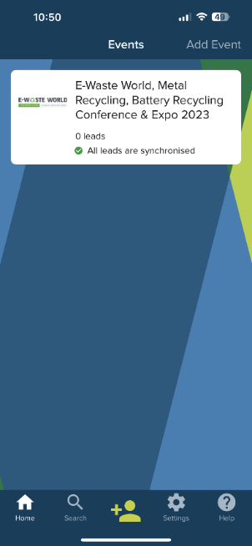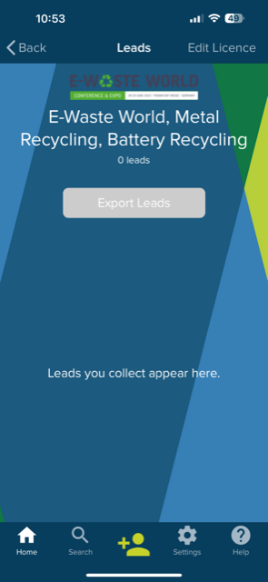
- To activate your portal, go to the confirmation email that contains the 3 steps. Click on the link that says – direct download.
- This takes you to a page where you can register yourself, add team members and add questions.
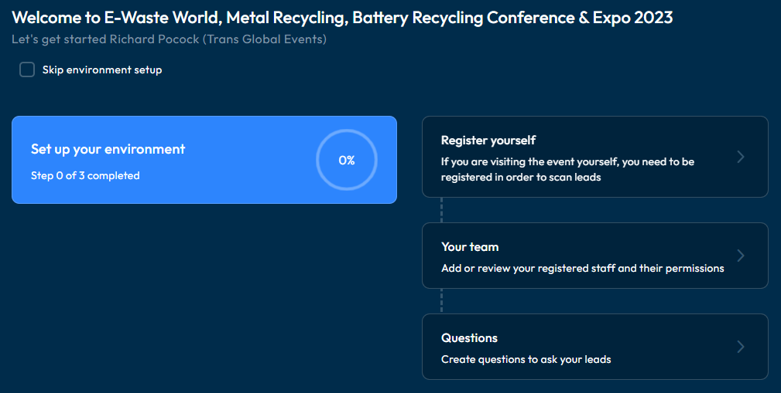
- The leads that you collect via the App can be accessed from this page. The Leads option on the left hand of the page will show your leads:
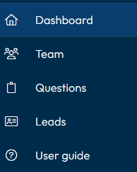

If you have any questions regarding the leads retrieval process, please contact leadretrieval@ukimediaevents.com

